

FINAL YEAR PROJECT REPORT (PROJECT STAGE – I)

ADVANCE FARMING SOLUTIONS

Submitted in partial fulfillment of the degree of Bachelor of Technology Rajasthan Technical University

By

Pushkar Jat(Pgi17cs034)

DEPARTMENT OF COMPUTER SCIENCE & ENGINEERING POORNIMA GROUP OF INSTITUTIONS, JAIPUR (Academic Year 2018-19)


FINAL YEAR PROJECT REPORT (PROJECT STAGE – I)

ADVANCE FARMING SOLUTIONS

Submitted in partial fulfillment of the degree of Bachelor of Technology Rajasthan Technical University

By

Pushkar Jat (PGI17Cs034)

DEPARTMENT OF COMPUTER SCIENCE ENGINEERING POORNIMA GROUP OF INSTITUTIONS, JAIPUR (Academic Year 2018-19)

Project No:

Guide: Mr. Bhanwar Veer Singh



RAJASTHAN TECHNICAL UNIVERSITY

POORNIMA GROUP OF INSTITUTIONS, JAIPUR

CERTIFICATE

This is to certify that Final Year Project Report (Project Stage – I) entitled “ADVANCE FARMING SOLUTIONS” has been submitted by “Pushkar Jat(PGI17CS034)” for partial fulfillment of the Degree of Bachelor of Technology of Rajasthan Technical University. It is found satisfactory and approved for submission.

Date:

Mr. Bhanwar Veer Singh | Mr. Manish Bhardwaj | Dr. Deepak Kumar
PRODUCT OWNER | HoD, | Principal,
Computer Engineering | Computer Engineering
PGI, Jaipur | PGI, Jaipur | PGI, Jaipur

ii



ABSTRACT

The Advance Faming Solutions is a project which will help the farmers to do the farming and the daily tasks associated to farming in a smart manner. We will be developing a hardware interface which will be installed on the farming land and an Android based application which will be installed in the smartphone of the farmer. This project has the objective to protect the crops from various damages caused by various factors which majorly include, lack of water or timely dripping of water in the land, trespassing of animals and creatures into the farming land and hence damaging the crops and human interference into farming land for some negative purposes.

Subject Description:
5CS4A Database Management Systems
3CS2A Data Structures & Algorithms

6CS6.2A Artificial Intelligence

4CS4A Software Engineering

Keywords:

Farming, Rural farming problems, Smart farming, Hybrid mobile application

Implementation Software(s) and Hardware(s):

MS-Windows, Internet Connectivity,

Android Device (v4.0 or above)

iii



ACKNOWLEDGEMENT

A project of such a vast coverage cannot be realized without help from numerous sources and people in the organization. We are thankful to Sh. Shashikant Singhi, Chairman, PF, Sh. Rahul Singhi, Director, PG and Dr. Deepak Kumar, Principal, PGI for providing us a platform to carry out such huge projects successfully.

We are also very grateful to Mr. Manish Bhardwaj, HOD, CE, PGI for his kind support.

We like to take this opportunity to show our gratitude towards Mr. Sumit Mathur, Project Coordinator, CE, PGI who helped us in successful completion of our Final Year Project Stage - I. He has been a guide, motivator & source of inspiration for us to carry out the necessary proceedings for the project to be completed successfully.

We are also grateful to the Mr. Bhanwar Veer Singh for his guidance and support.

We are thankful to Mr. Purshottam Agarwal for his kind support and providing us expertise of the domain to develop the project.

We are also privileged to have Mr. Chandan Kumar Dubey and other faculty members who have flourished us with their valuable facilities without which this work cannot be completed.

We would also like to express our hearts felt appreciation to all of our friends whom direct or indirect suggestions help us to develop this project and to entire team members for their valuable suggestions.

Lastly, thanks to all faculty members of Department of Computer Science Department of for their moral support and guidance.

Submitted by: Pushkar Jat

Team Members:

Pushkar Jat

iv

Project Charter

Project Title:

ADVANCE FARMING SOLUTIONS

Project Description:

The Advance Faming Solutions is a project which will help the farmers to do the farming and the daily tasks associated to farming in a smart manner. We will be developing a hardware interface which will be installed on the farming land and an Android based application which will be installed in the smartphone of the farmer. This project has the objective to protect the crops from various damages caused by various factors which majorly include, lack of water or timely dripping of water in the land, trespassing of animals and creatures into the farming land and hence damaging the crops and human interference into farming land for some negative purposes.

Users:

- Farmers

- Persons related with Farming

Project Requirements:

- The user has to connect its mobile with the setup.

- Only the farmer or his nominee can access the setup.

- The user can monitor the activities taking place on the land.

- The user should have an Android phone.

- The user should have a good internet connection in the phone.

Assigned Project manager and Authority Level:

User | Authority Level
Project Team Members | Root level access
Clients | All the functionalities and key features
Normal Users | All the functionalities and key features

Table (i): Project Users with Authority Levels

v

Assumptions and Constraints:

- User must have a mobile phone.

- User must have an internet connection.

- The user has installed android v4.0 or above.

Business Case:

- User has to install this application to use currency recognition system without any cost.

- Currency support code is only accessible to the developers/administrators.

vii

 |  |  |  | Table of Content
 | S. No. | Description |  |  | Page No.
 | 1. | Title |  |  | (i)
2. |  | Certificate |  |  | (ii)
3. |  | Abstract |  |  | (iii)
4. |  | Acknowledgement |  |  | (iv)
5. |  | Project Charter |  |  | (v)
6. |  | Chapter 1: |  | Client Survey and Result | 1
 |  | 1.1 | Client Survey |  | 1
 |  | 1.2 | Projects Description |  | 1
 |  |  | 1.2.1 | Advance College Management System | 1
 |  |  | 1.2.2 | File Encryption Utility Application | 2
 |  |  | 1.2.3 | Advance Farming Solutions | 2
 |  | 1.3 | Result |  | 2
7. |  | Chapter 2: |  | Requirements of Client | 3
 |  | 2.1 | Client Requirement |  | 3
 |  | 2.2 | Project Objective |  | 3
 |  | 2.3 | Project Requirement |  | 3
8. |  | Chapter 3: |  | Introduction | 4
9. |  | Chapter 4: |  | Functional Requirements | 5
 |  | 4.1 | Project Requirement |  | 5
 |  | 4.2 | Functional Requirement |  | 5
 |  | 4.3 | Non-functional Requirement |  | 5
10. |  | Chapter 5: |  | Tools and Technology Used | 6
 |  | 5.1 | Tools Used |  | 6
 |  | 5.2 | Technology Used |  | 6
 |  |  | 5.2.1 | IoT | 6
 |  |  | 5.2.2 | HTML/CSS | 8
 |  |  | 5.2.3 | Bootstrap | 11
 |  |  | 5.2.4 | Web Application | 14
 |  |  | 5.2.5 | NodeMCU | 15
11. |  | Chapter 6: |  | Methodology Used | 19
 |  | 6.1 | Scrum |  | 19
 |  | 6.2 | Scrum management |  | 19
 |  | 6.3 | Scrum development |  | 19
 |  | 6.4 | Scrum concepts |  | 20
 |  |  | 6.4.1 | Burndown chart | 20
 |  |  | 6.4.2 | Product backlog | 20
 |  |  | 6.4.3 | ScrumMaster | 20
 |  |  | 6.4.4 | Sprint backlog | 20
 |  | 6.5 | Conclusion and future work |  | 21
12. |  | Chapter 7: |  | Product Used | 22
 |  | 7.1 | What is Advance Farming Solutions? |  | 22

viii



 |  | 7.1.1 | Home Screen | 22
 |  | 7.1.2 | Main Screen | 22
 | 7.2 | Users |  | 23
 | 7.3 | Functional Requirement |  | 23
13. | Chapter 8: |  | Process Flow Diagram | 24
 | 8.1 |  | Sequence Diagram | 24
14. | Chapter 9: |  | User Stories | 25
 | 9.1 | Initial User Stories (Informal) |  | 25
 | 9.2 | Initial User Stories (Formal) |  | 25
 | 9.3 | User Story Life Cycle |  | 25
15. | Chapter 10: |  | User Story Cards | 26
 | 10.1 | Epic – I User Story Card (Informal) |  | 26
 | 10.1 | Epic – II User Story Card (Informal) |  | 26
16. | Chapter 11: |  | Software Requirement Specifications | 27
 | 11.1 | Introduction |  | 27
 |  | 11.1.1 | Feasibility | 27
 | 11.2 | Functional/Non-functional requirement |  | 28
 |  | 11.2.1 | Functional requirements | 28
 |  | 11.2.2 | Non-functional requirement | 28
 | 11.3 | Technical requirement |  | 28
 |  | 11.3.1 | Operating environment | 28
 |  | 11.3.2 | Hardware requirements | 28
 |  | 11.3.3 | Software requirements | 29
 | 11.4 | Use-Case diagram |  | 29
 | 11.5 | Assumptions and Dependencies |  | 29
17. | Chapter 12: |  | Sprint Backlog – 1 | 30
 | 12.1 | Introduction to Spring Backlog - 1 |  | 30
 | 12.2 | Sprint Backlog Chart |  | 30
 | 12.3 | Conclusion |  | 33
18. | Chapter 13: |  | Sprint Backlog – 2 | 41
 | 13.1 | Introduction to Spring Backlog - 2 |  | 41
 | 13.2 | Sprint Backlog Chart |  | 41
 | 13.3 | Study |  | 42
 |  | 13.3.1 | Layout Designing | 42
 |  | 13.3.2 | Coding(HTML/CSS/Bootstrap) | 44
 | 13.4 | Arduino based Coding for Hardware Setup |  | 46
 | 13.5 | Arduino based Coding for GUI |  | 49
 | 13.6 | Conclusion |  | 50

- Chapter 14:Achievements- Module Requirements Vs

Fulfilled Requirements | 51

- Chapter 15:Detailed Report from Client and

 |  | Recommendation | 52
21. | Chapter 16: | Report from Guide and Recommendation | 53

ix

22. | Chapter 17: | Future Scope of Work | 54
23. | Chapter 18: | FAQs About Projects | 55
24. | Chapter 19: | Project Summary | 56
25. | Chapter 20: | Appendices | 57
26. | Chapter 21: | References | 58

x

 |  | Table of figures
 | S. No. | Description | Page No.
 | 1. | Figure 1: Cycle of Project Setup | 9
2. |  | Figure 2: IoT | 9
3. |  | Figure 3: Environment Monitoring | 11
4. |  | Figure 4: Infrastructure Management | 13
5. |  | Figure 5: Industrial Management | 14
6. |  | Figure 6: Smart Housing | 16
7. |  | Figure 7: HTML5 | 16
8. |  | Figure 8: Functions of CSS | 20
9. |  | Figure 9: Layout of CSS | 24
10. |  | Figure 10: Bootstrap | 24
11. |  | Figure 11: Web Application | 25
12. |  | Figure 12: NodeMCU | 29
13. |  | Figure 13: NodeMCU Pin Diagram | 38
14. |  | Figure 14: Sensors | 38
15. |  | Figure 15: Scrum Development Process | 39
16. |  | Figure 16: Burndown Chart | 39
17. |  | Figure 17: Process Diagram | 42
18. |  | Figure 18: Sequence Diagram | 45
19. |  | Figure 19: User Story Life Cycle | 49
20. |  | Figure 20: Use Case Diagram | 54
21. |  | Figure 21: Class Diagram | 57
22. |  | Figure 22: High Level Design | 58

xi

 |  | Table of content-tables
 | S. No. | Description | Page No.
 | 1. | Table (i): Project Users with Authority Levels | (v)
2. |  | Table (ii): Project Schedule | (vi)
3. |  | Table 5.1: function f(x,y) values at certain point | 15
4. |  | Table 10.1: User Story Card Epic-I | 26
5. |  | Table 10.2: User Story Card EPIC-II | 26
6. |  | Table 12.1: Sprint Backlog Chart - 1 | 30
7. |  | Table 13.1: Sprint Backlog Chart – 2 | 41
8. |  | Table 20.1: Appendices | 57

xii

CHAPTER-1

CLIENT SURVEY AND RESULT (DETAILS)

2.1 Client Survey:

The voice of the client is valuable for any project either it is big or small. What they have to say can mean the difference between a successful project and a disappointing one. Listen to client’s opinions about project service and quality. Hearing from clients about their experiences, we’ll be in a much better position to offer the best products and superior client services that will make them loyal clients.

2.2 Projects Description:

Going so far, before finalizing three projects are selected as follows:

2.2.1 Advance College Management System:

Description: Advance college management system is a web application (mobile application as well as website) which allows various tasks to perform as follows:
- For student:
  - Profile manipulation

  - Online attendance viewer
  - Online internal marks viewer
  - Online E-Quiz portal for enhancing skills
  - E-Materials regarding previous papers and solutions

- For faculty members:

  - Profile manipulation
  - Online instant attendance system
  - Internal marks entry panel

- Other services:

  - Event management
  - Transport management with GPS location
  - Scholarship and fee notification

  - Subject information entry panel

Technology: To develop such kind of project following languages are used:
- For website: HTML, CSS, JS, JQuesy, BootStrap, AJAX, JSP, Servlets

- For mobile application: IONIC framework, TypeScript, Angular2
- For database: MySQL, Firebase

Client: Poornima Group of Institutions, Jaipur

13

2.2.2 File Encryption Utility Application:

Description: File Encryption utility is a simple tool for encrypting both text and binary files using the blowfish encryption algorithm. The utility can create a self extracting encrypted file.

Features: File Encryption Utility Has the following features:
- Fast & Quick File Encryption/Decryption

- Internal File Wiping Utility

- Creating Self-Extracting Encrypted File
- Explorer Integration

- Support configuration dialog

- Command Line Parameters

Technology: To develop file encryption utility application native C++ and ATL library will be used. The Active Template Library (ATL) is a set of template-based C++ classes developed by Microsoft, intended to simplify the programming of Component Object Model (COM) objects. The COM support in Microsoft Visual C++ allows developers to create a variety of COM objects, OLE Automation servers, and ActiveX controls.

Client: Mr. Sunil Sharma, Director, HawksCode s/w Pvt. Ltd, Jaipur

2.2.3 Advance Farming Solutions

Description: The Advance Faming Solutions is a project which will help the farmers to do the farming and the daily tasks associated to farming in a smart manner. We will be developing a hardware interface which will be installed on the farming land and an Android based application which will be installed in the smartphone of the farmer. This project has the objective to protect the crops from various damages caused by various factors which majorly include lack of water or timely dripping of water in the land, trespassing of animals and creatures into the farming land and hence damaging the crops and human interference into farming land for some negative purposes.

This setup will generate an alarm in the application installed on the phone of the farmer if any interference is recorded in the farm so that he can take suitable actions. Apart from this, it will also automatically generate a notification which will be informing the farmer to start or stop the dripping in the field accordingly.

Technology: To develop Advance Farming Solutions, IoT framework is used which included various platforms for development like HTML/CSS, Arduino, Embedded Systems

Client: Mr. Bhanwar Veer Singh

2.3 Result:

After Discussing with respected HOD, project coordinator and guide, Advance Farming Solutions is chosen as final project for further development.

14

CHAPTER-2

REQUIREMENTS OF CLIENT

3.1 Client requirements:

Advance Farming Solutions is a smart solutions to most of the problems faced by the farmers regarding their farming land.

A farmer nowadays is very much concerned about his crops and very much possessive about the protection of his crops. Also, due to the damage in the crops many farmers are also committing suicides. And as a solution for the same, he can do nothing about this. Apart from just the issues regarding protection of the crops there exists issues like the start and stop of dripping systems of water in his farm. So to protect the farmer from the loss from various problems we are presenting some advance farming solutions which will not only solve their issues but will also save their time.

Whether it be the destruction of their crops by a human with negative intentions or trespassing done by any creature or an animal which can destroy the crops. This project will the solutions to all these solutions where the farmer will be easily able to monitor the crops at the ease and comfort of his home and that too on his smart phone.

3.2 Project objective:

The major objectives of this project are:-

- To help the farmers to solve daily farming issues.

- To save their time and energy by getting them some advance solutions to their problems.

- To digitalize the complete working method of farmers related with their crops.

3.3 Project Requirement:

Following are the project requirement to provide all the functionalities:
- The user should have a smartphone

- Smartphone must consist of an internet connection

- In case of android, installed android OS version should be 4.0 or higher
- To confirm proper functioning, internet and mobile must be properly functional.

15

CHAPTER-3

INTRODUCTION

The Advance Faming Solutions is a project which will help the farmers to do the farming and the daily tasks associated to farming in a smart manner. We will be developing a hardware interface which will be installed on the farming land and an Android based application which will be installed in the smartphone of the farmer. This project has the objective to protect the crops from various damages caused by various factors which majorly include, lack of water or timely dripping of water in the land, trespassing of animals and creatures into the farming land and hence damaging the crops and human interference into farming land for some negative purposes.

This setup will generate an alarm in the application installed on the phone of the farmer if any interference is recorded in the farm so that he can take suitable actions. Apart from this, it will also automatically generate a notification which will be informing the farmer to start or stop the dripping in the field accordingly.

A farmer nowadays is very much concerned about his crops and very much possessive about the protection of his crops. Also, due to the damage in the crops many farmers are also committing suicides. And as a solution for the same, he can do nothing about this. Apart from just the issues regarding protection of the crops there exists issues like the start and stop of dripping systems of water in his farm. So to protect the farmer from the loss from various problems we are presenting some advance farming solutions which will not only solve their issues but will also save their time.

For this concept we will provide a hybrid app for Android interfaced with Hardware Setup installed on the farming land, so that the users can run the application and take proper care of his crops and agriculture land.
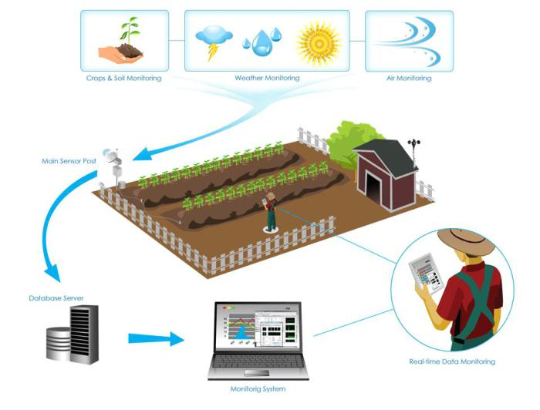

Fig. 1: Cycle of Project Setup

16

CHAPTER-4

FUNCTIONAL REQUIREMENTS

4.1 Project requirement:

Following are the project requirement to provide all the functionalities:
- The user should have a smartphone
- Smartphone must consist of an internet connection

- In case of android, installed android OS version should be 4.0 or higher

- To confirm proper functioning, internet and mobile must be properly functional.

4.2 Functional requirements:

A functional requirement defines a function of a system or its component. A function is described as a set of inputs, the behavior, and outputs. Functional requirements may be calculations, technical details, data manipulation and processing and other specific functionality that define what a system is supposed to accomplish.

- A mobile application that can record data of happenings on the farming land and can monitor every occurrence
- The application should be able to retrieve results from setup installed comprising of various sensors from the data stored on the cloud

- The webpage should be bootstrapped and must be functional for both laptops and mobile phones.

4.3 Non-functional requirement:

A non-functional requirement (NFR) is a requirement that specifies criteria that can be used to judge the operation of a system, rather than specific behaviors. Non-functional requirements are often called "quality attributes" of a system. Other terms for non-functional requirements are "qualities", "quality goals", "quality of service requirements", "constraints" and "non-behavioral requirements".

- There should be minimal lag while recording the data from the land and sending over the cloud.
- The components installed on the ground must be properly functional

- The system should give valid result for positive as well as negative test cases
- The proposed system should be able to identify every change in the environment in every 1 minute.

1

CHAPTER-5

TOOLS AND TECHNOLOGY USED

5.1 Tools used:

- IoT

- HTML/CSS
- Bootstrap

- Web Application

- NodeMCU
- Sensors

5.2 Technology used:

Technology plays a vital role in development of a project to achieve efficiency as well as accuracy. A project should be able to compute accurate output with maximum efficiency hence new, robust, efficient and trustworthy technology should be chosen as per the requirement.

5.2.1 Internet of Things (IoT)

The Internet of Things (IoT) is said to the network of physical devices, appliances, vehicles and such other items which entrenched with electronics, software configurations, several sensors, actuators and connectivity which enables all of these things to connect, collect and exchange data on and over the internet.

IoT basically comprises basically of multiple technologies which tends to produce real

time analytics machine learning, commodity sensors, and embedded systems. Traditional fields of embedded systems, wireless sensor networks, control systems, automation (including home and building automation), and others all contribute to enabling the Internet of things.

The term "Internet of things" was likely coined by Kevin Ashton of Procter & Gamble,

later MIT's Auto-ID Center, in 1999, though he prefers the phrase "Internet for things". At that point, he viewed Radio -frequency identification (RFID) as essential to the Internet of things, which would allow computers to manage all individual things.
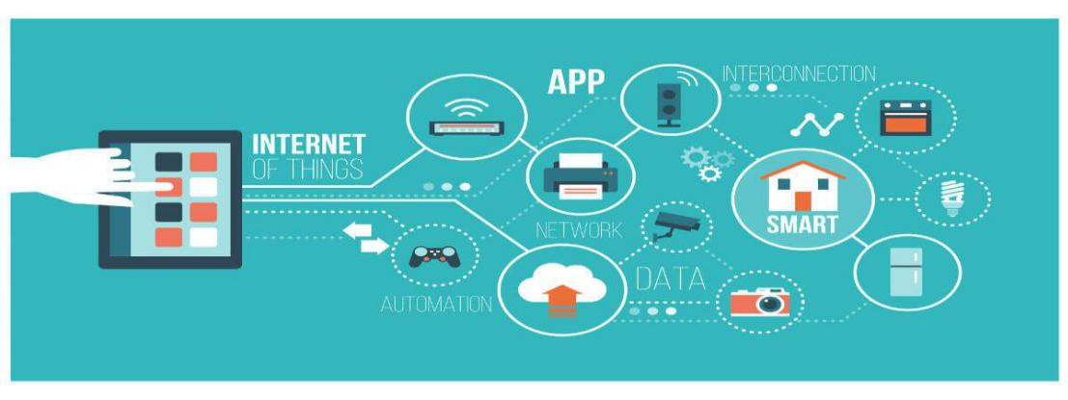

Fig. 2: IoT

2

5.2.1.1 Why should we use IoT?

In today’s time, IoT has proved itself to be most emerging and trending technology of the era. It is said to automate the devices and appliances and one can easily control them using internet and monitor their appliances and frameworks by the comfort of several clicks and taps.

Following are some major points which prove some major points why describes why IoT should be used:

- Monitoring of Environment: It is said to monitor the current environmental situations and predict the upcoming environmental changes based on the previous data stored and calculations made on it.
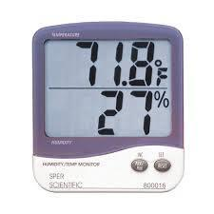

Fig.3: Environment Monitoring

- Infrastructure Management: It is said to monitor and track if there’s any issue arising from the infrastructure of rural or urban area. It will send data to the ministry which is responsible tio take care of the same.
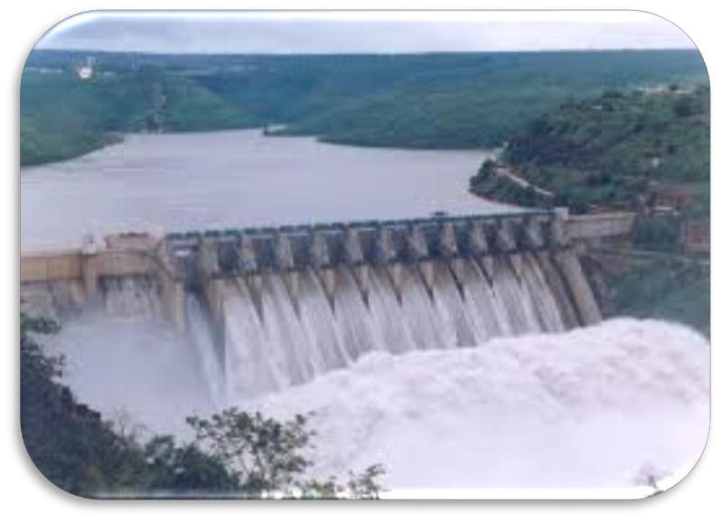

Fig. 4: Infrastructure Management

3

- Industrial Management: It is said to investigate the product and record its data and informs about the maintenance of the same for the purpose of optimizing to obtain a good market in the corporate sector.
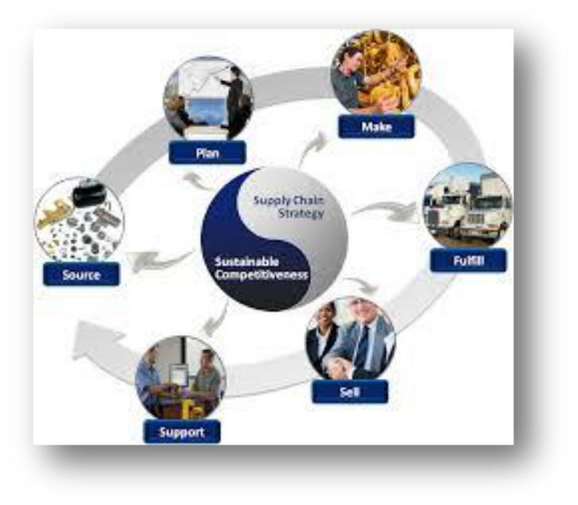

Fig.5: Industrial Management

- Building and Home Automation: IoT is best emerging in producing automated and controlled home appliances and other products of the home and that too with the minimal energy consumption.
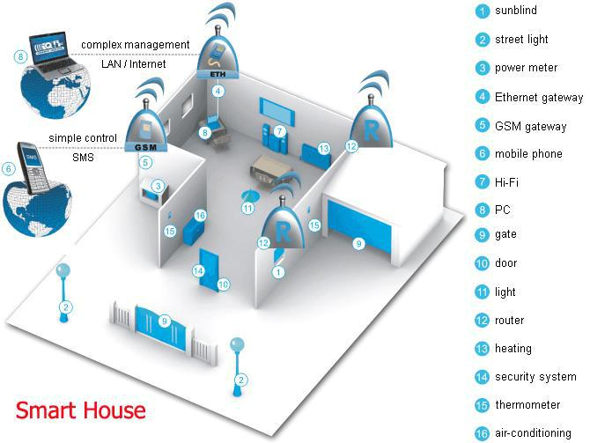

Fig. 6: Smart Housing

4

5.2.1.2 Advantages of IoT

Following are some of the most commonly known IoT Advantages −

- Data: The more the information, the easier it is to make the right decision. Knowing what to get from the grocery while you are out, without having to check on your own, not only saves time but is convenient as well.

- Tracking: The computers keep a track both on the quality and the viability of things at home. Knowing the expiration date of products before one consumes them improves safety and quality of life. Also, you will never run out of anything when you need it at the last moment.

- Time: The amount of time saved in monitoring and the number of trips done otherwise would be tremendous.

- Money: The financial aspect is the best advantage. This technology could replace humans who are in charge of monitoring and maintaining supplies.

5.2.2 HTML/CSS

HTML is the standard markup language for creating Web pages. HTML stands for Hyper Text Markup Language. HTML describes the structure of Web pages using markup. Its elements are the building blocks of HTML pages. Its elements are represented by tags. HTML tags label pieces of content such as "heading", "paragraph", "table", and so on. Browsers do not display the HTML tags, but use them to render the content of the page. Now that we’ve gotten the basic theory out of the way. It’s time to learn how to build our first website.

First off, we must ensure that we have the right tools. Most importantly, we need an HTML editor. There are many choices on the market such as the extremely popular Notepad++. However, for this tutorial, we will use the Bluefish Editor as it is free and also offers cross platform support for Windows, Mac, and Linux users. If you don't want to install any software, but want to preview code instantly — you can use an online HTML editor such as this simple html5 editor.


Fig.7: HTML5

5

5.2.2.1 CSS

Cascading Style Sheets or CSS which is used to enhancing the presentation of a webpage to a great extent and which is basically used to decorate the pages to make them look beautiful and attractive.

The major goal of CSS lies in the fact that it enables the separation of presentation and content including some layout which is properly padded, colors and fonts.

Its specifications and characteristics are maintained and managed by the World Wide Web Consortium.

It also has a simple syntax and also uses a number English language words to specify the names and properties of the functions and methods in the sheets. It actually consists a long list of rules and each of them consists of different rule set used to make up a single sheet and declaration blocks. The major goal of CSS lies in the fact that it enables the separation of presentation and content including some layout which is properly padded, colors and fonts. Its specifications and characteristics are maintained and managed by the World Wide Web Consortium.

The major goal of CSS lies in the fact that it enables the separation of presentation and content including some layout which is properly padded, colors and fonts.

Its specifications and characteristics are maintained and managed by the World Wide Web Consortium. Cascading Style Sheets or CSS which is used to enhancing the presentation of a webpage to a great extent and which is basically used to decorate the pages to make them look beautiful and attractive.
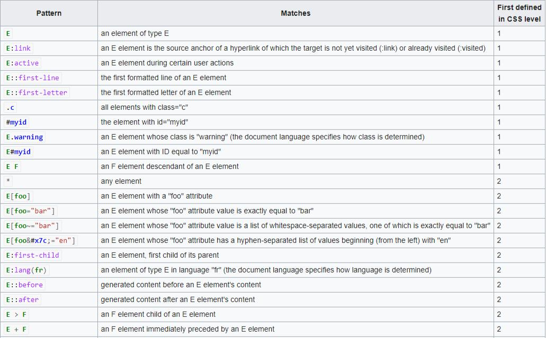

FIg.8: Functions of CSS

6

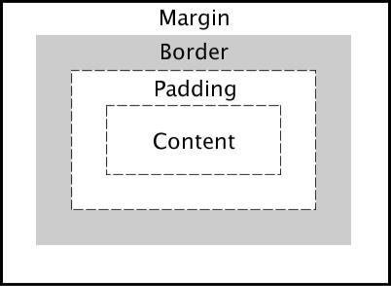

Fig.9: Layout of CSS

5.2.3 Bootstrap:

Bootstrap is a completely free and open source framework which is used for front end purposes for the purpose of designing webpages and web applications. It constitutes of HTML and also CSS dependent design templates for the typography, forms, buttons, navigation and other purpose all and also is able to make the webpage functional on both the desktop screen as well as small sized cellphones also.

Bootstrap makes it feasible to use those web pages in both the formats and that too in a very simple format. Since it is free and openly available so everyone can use it and make the ir web application more catchy and feasible to work in any condition.

Bootstrap is a completely free and open source framework which is used for front end purposes for the purpose of designing webpages and web applications. It constitutes of

7

HTML and also CSS dependent design templates for the typography, forms, buttons, navigation and other purpose all and also is able to make the webpage functional on both the desktop screen as well as small sized cellphones also.
Bootstrap makes it feasible to use those web pages in both the formats and that too in a very simple format. Since it is free and openly available so everyone can use it and make their web application more catchy and feasible to work in any condition.

Bootstrap, originally named Twitter Blueprint, was developed by Nirav Panchal and Jacob Thornton at Twitter as a framework to encourage consistency across internal tools. Before Bootstrap, various libraries were used for interface development, which led to inconsistencies and a high maintenance burden. According to twitter developer Mark Otto:

"A super small group of developers and I got together to design and build a new internal tool and saw an opportunity to do something more. Through that process, we saw ourselves build something much more substantial than another internal tool. Months later, we ended up with an early version of Bootstrap as a way to document and share common design patterns and assets within the company."
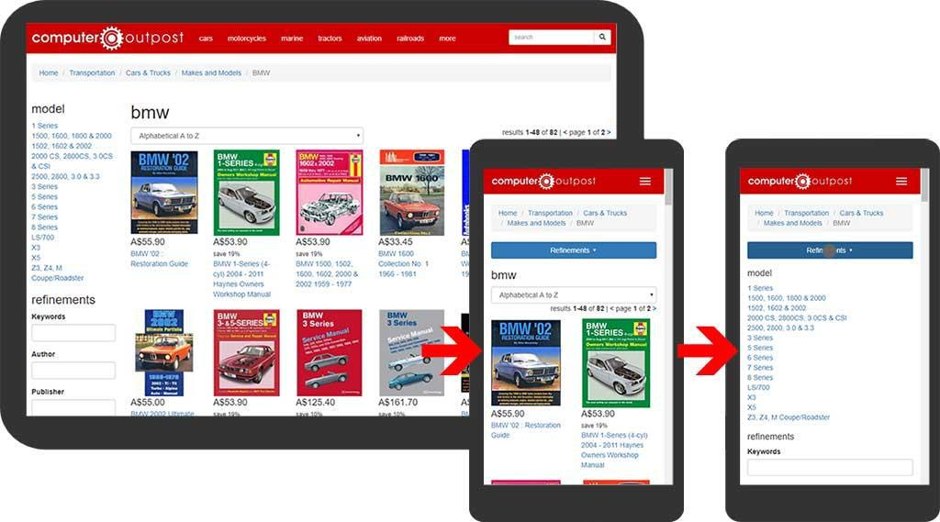

Fig.9: Bootstrap

8

5.2.4 Web Application:

A web application is basically a client server computer program which the client runs in a web browser. Various examples of the web applications can be webmail, online retail sales, and online auction. The general distinction between a dynamic web page of any kind and a "web application" is unclear. Web sites most likely to be referred to as "web applications" are those which have similar functionality to a desktop software application, or to a mobile app. HTML5 introduced explicit language support for making applications that are loaded as web pages, but can store data locally and continue to function while offline.

Single-page applications are more application-like because they reject the more typical web paradigm of moving between distinct pages with different URLs. Single-page frameworks like Sencha Touch and AngularJS might be used to speed development of such a web app for a mobile platform.

Out of all these signals, the field that deals with the type of signals for which the input is an image and the output is also an image is done in image processing. As it name suggests, it deals with the processing on images.

It can be further divided into analog image processing and digital image processing.

The general distinction between a dynamic web page of any kind and a "web application" is unclear. Web sites most likely to be referred to as "web applications" are those which have similar functionality to a desktop software application, or to a mobile

app. HTML5 introduced explicit language support for making applications that are loaded as web pages, but can store data locally and continue to function while offline.
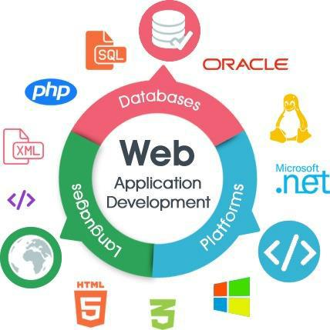

Fig.10: Web Application

9

5.2.5 NodeMCU

NodeMCU is an open source IoT platform which includes firmware which runs on the ESP8266 Wi-Fi SoC and hardware which is based on the ESP-12 module. The term "NodeMCU" by default refers to the firmware rather than the development kits. The firmware uses the Lua scripting language. It is based on the eLua project, and built on the Espressif Non-OS SDK for ESP8266. It uses many open source projects, such as lua-cjson, and spiffs. The term "NodeMCU" by default refers to the firmware rather than the development kits. The firmware uses the Lua scripting language. It is based on the eLua project, and built on the Espressif Non-OS SDK for ESP8266. It uses many open source projects, such as lua-cjson, and spiffs.

As Arduino.cc began developing new MCU boards based on non-AVR processors like the ARM/SAM MCU and used in the Arduino Due, they needed to modify the Arduino IDE so that it would be relatively easy to change the IDE to support alternate tool chains to allow Arduino C/C++ to be compiled down to these new processors. They did this with the introduction of the Board Manager and the SAM Core. A "core" is the collection of software components required by the Board Manager and the Arduino IDE to compile an Arduino C/C++ source file down to the target MCU's machine language. Some creative ESP8266 enthusiasts have developed an Arduino core for the ESP8266 WiFi SoC that is available at the GitHub ESP8266 Core webpage. This is what is popularly called the "ESP8266 Core for the Arduino IDE" and it has become one of the leading software development platforms for the various ESP8266 based modules and development boards, including NodeMCUs.

As Arduino.cc began developing new MCU boards based on non-AVR processors like the ARM/SAM MCU and used in the Arduino Due, they needed to modify the Arduino IDE so that it would be relatively easy to change the IDE to support alternate tool chains to allow Arduino C/C++ to be compiled down to these new processors.
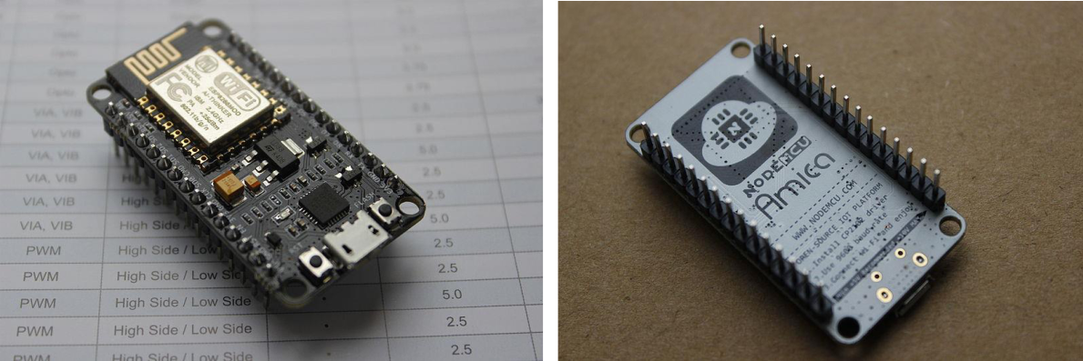

Fig.12(a): NodeMCU Fig.12(b): NodeMCU Pins

10

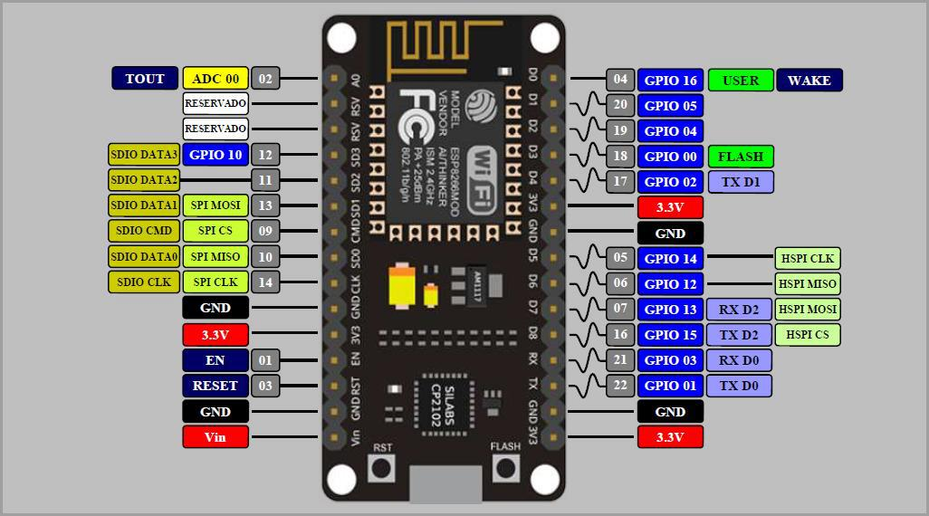

Fig.13: NodeMCU Pin Diagram

11

5.2.6 Sensors

A sensor is a device, module or a subsystem whose purpose is to detect events or changes in its environment and send the information to other electronics, frequently a computer processor. A sensor is always used with other electronics, whether as simple as a light or as complex as a computer.

Sensors are used in everyday objects such as touch-sensitive elevator buttons (tactile sensor) and lamps which dim or brighten by touching the base, besides innumerable applications of which most people are never aware. With advances in micromachinery and easy-to-use microcontroller platforms, the uses of sensors have expanded beyond the traditional fields of temperature, pressure or flow measurement,^{[1]} for example into MaRG sensors. Moreover, analog sensors such as potentiometers and force-sensing resistors are still widely used. Applications include manufacturing and machinery, airplanes and aerospace, cars, medicine, robotics and many other aspects of our day-to-day life.

In physical world, any quantity measurable through time over space or any higher dimension can be taken as a signal. A signal is a mathematical function, and it conveys some information.

A signal can be one dimensional or two dimensional or higher dimensional signal. One dimensional signal is a signal that is measured over time. The common example is a voice signal.

The two dimensional signals are those that are measured over some other physical quantities. The example of two dimensional signal is a digital image. We will look in more detail in the next tutorial of how a one dimensional or two dimensional single and higher signals are formed and interpreted.
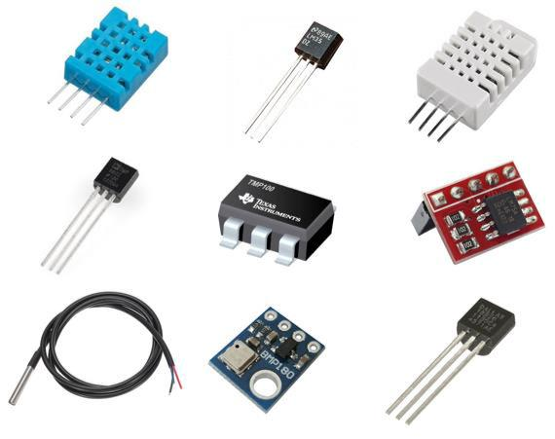

Fig.14: Sensors

12

CHAPTER-6

METHODOLOGY USED

6.1 Scrum:

In rugby, ‘scrum’ (related to “scrimmage”) is the term for a huddled mass of players engaged with each other to get a job done. In software development, the job is to put out a release. Scrum for software development came out of the rapid prototyping community because prototypes wanted a methodology that would support an environment in which the requirements were not only incomplete at the start, but also could change rapidly during development.5 Unlike XP, Scrum methodology include both managerial and development processes.

6.2 Scrum management:

At the center of each Scrum project is a backlog of work to be done. This backlog is populated during the planning phase of a release and defines the scope of the release (see Figure). After the team completes the project scope and high-level designs, it divides the development process into a series of short iterations called sprints. Each sprint aims to implement a fixed number of backlog items (see Figure). Before each sprint, the team members identify the backlog items for the sprint. At the end of a sprint, the team reviews the sprint to articulate lessons learned and check progress.

During a sprint, the team has a daily meeting called a scrum. Each team member describes the work to be done that day, progress from the day before, and any blocks that must be cleared. To keep the meetings short, the scrum is supposed to be conducted with everyone in the same room—standing up for the whole meeting.

When enough of the backlog has been implemented so that the end users believe the release is worth putting into production, management closes development. The team then performs integration testing, training, and documentation as necessary for product release.

6.3 Scrum development:

The Scrum development process concentrates on managing sprints. Before each sprint begins, the team plans the sprint, identifying the backlog items and assigning teams to these items. Teams develop, wrap, review, and adjust each of the backlog items (See Figure 6.1).

During development, the team determines the changes necessary to implement a backlog item. The team then writes the code, tests it, and documents the changes. During wrap, the team creates the executable necessary to demonstrate the changes. In review, the team demonstrates the new features, adds new backlog items, and assesses risk. Finally, the team consolidates data from the review to update the changes as necessary.

13

Following each sprint, the entire team—including management, users, and other interested parties—demonstrates progress from the sprint and reviews the backlog progress. The team then reviews the remaining backlog and adds, removes, or reprioritizes items as necessary to account for new information and understanding gathered during the sprint.
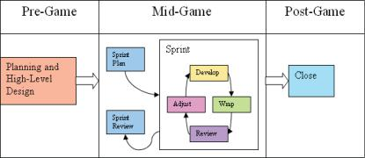

Fig.15:Scrum development process

6.4 Scrum concepts:

Here are a few of the most important concepts:

6.4.1 Burndown chart:

This chart, updated every day, shows the work remaining within the sprint. The burndown chart is used both to track sprint progress and to decide when items must be removed from the sprint backlog and deferred to the next sprint.

14

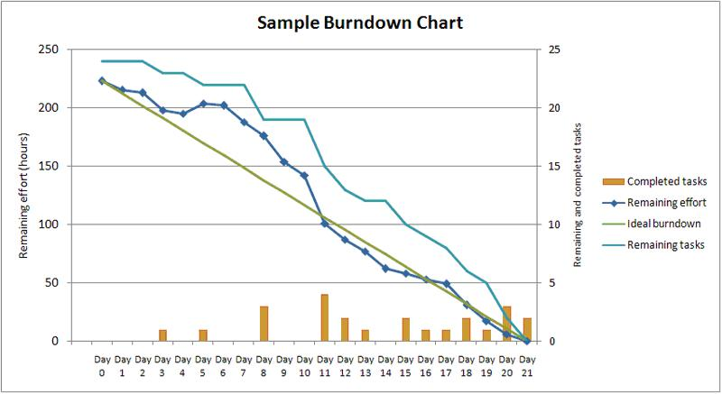

Fig.16: Burndown Chart

6.4.2 Product backlog:

Product backlog is the complete list of requirements—including bugs, enhancement requests, and usability and performance improvements—that are not currently in the product release.

6.4.3 ScrumMaster:

The ScrumMaster is the person responsible for managing the Scrum project. Sometimes it refers to a person who has become certified as a ScrumMaster by taking ScrumMaster training.

6.4.4 Sprint backlog:

Sprint backlog is the list of backlog items assigned to a sprint, but not yet completed. In common practice, no sprint backlog item should take more than two days to complete. The sprint backlog helps the team predict the level of effort required to complete a sprint.

6.5 Conclusion and future work:

Our tool is based on the agile software development using scrum methodology. Tool manages the development process involved in software project industry. By Changes over some traditional method of agile software development can improve the previous solution for project resource planning and management. These changes produce a revolutionary effect on planning and management. In future we improve more features of our tool to make things more transparent and flexible.

15

CHAPTER-7

PRODUCT BACKLOG

The following product backlog is written for the “Advance Farming Solutions”project setup. This product backlog lists everything that the product owner and Advance Farming Solutions team feels, should be included in the application:

7.1 What is ADVANCE FARMING SOLUTIONS?

A farmer nowadays is very much concerned about his crops and very much possessive about the protection of his crops. Also, due to the damage in the crops many farmers are also committing suicides. And as a solution for the same, he can do nothing about this. Apart from just the issues regarding protection of the crops there exists issues like the start and stop of dripping systems of water in his farm. So to protect the farmer from the loss from various problems we are presenting some advance farming solutions which will not only solve their issues but will also save their time.

7.1.1 Home Page (Application Side)

- As an application developer, I want to have a prominent area on the home page where I can put special buttons and functionalities by which the farmer will be controlling the farming land.

- As an application user, I want to see easily usable functional buttons as I’m not much literate.

- As an application user, I want to know every trespassing being done in the agriculture land.

- As an application user, I want to be very much friendly to the application so it becomes very easy for me to pursue the motive of this application and setup.

7.1.2Register & Interface

- As the user of the application, I want to interface the hardware setup with the application in a very simple way. A

- As an application developer, I will make sure the connectivity between the hardware setup and the application remains smooth.

- As a hardware setup assembler, I will ensure that the functioning of the Bluetooth devices and GSM module implanted works smoothly

16

7.1.3 Main Screen

- As a user of the application, I will be able to monitor the data recorded by the sensors.

- As a user of the application, I will be observing the temperature, humidity and soil moisture content of the farming land.
- As a user of the application, I will be able to check the status of the water pump.

- As a user of the application, I will be able to on/off the water pump depending on the soil moisture and humidity content.

7.2 Users:

- Farmer
- Developer

7.3 Functional Requirement:

A functional requirement defines a function of a system or its component. A function is described as a set of inputs, the behavior, and outputs. Functional requirements may be calculations, technical details, data manipulation and processing and other specific functionality that define what a system is supposed to accomplish.

- The android application and the hardware setup will be interfaced.

- User can easily perform their daily task.

- User can easily implement the functionalities of the application.

- Only registered user can interface with the setup.

- The app will not take any action without the consent of farmer.

17

CHAPTER-8

PROCESS FLOW DIAGRAM
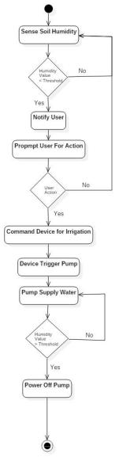

Fig.17: Process Diagram

18

8.1 Sequence Diagram:
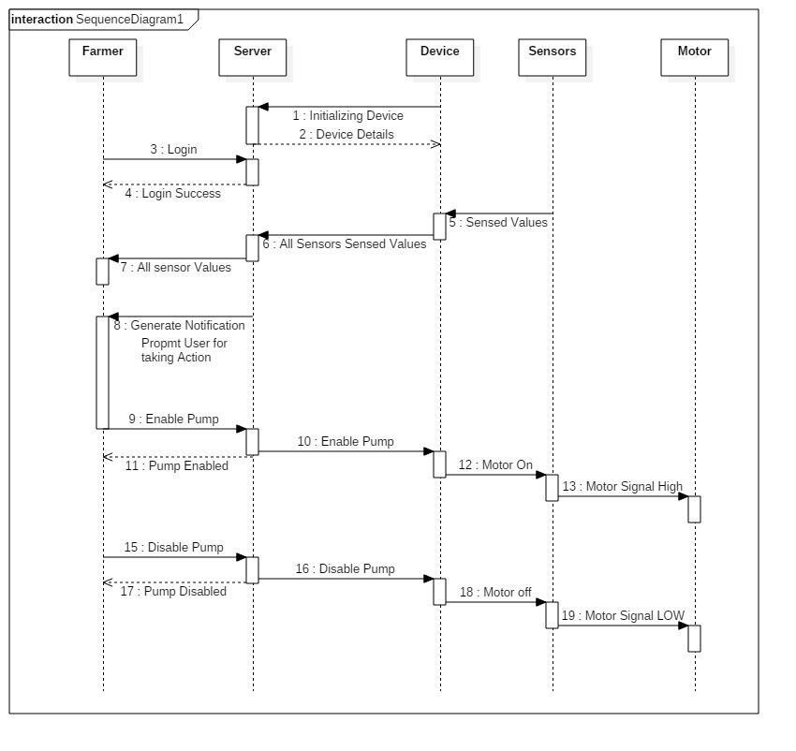

Fig.18: Sequence Diagram

19

CHAPTER-9

USER STORIES

User stories are one of the primary development artifacts for Scrum project teams. A user story is a very high-level definition of a requirement, containing just enough information so that the developers can produce a reasonable estimate of the effort to implement it. For COINAGE, user story is as follows:

9.1 Initial User Stories (Informal):

- User can see data recorded of the farming land.

- User can process and review data at any time.
- User can also monitor the status of water pump.

- User can control the working status of water pump.

- User can also view the activities on his phone.

9.2 Initial User Stories (Formal):

- As an end user, I want to see data recorded of the farming land
- As an end user, I want to process and review data at any time

- As an end user, I want to monitor the status of water pump

- As an end user, I want to view the activities on his phone

9.3 User Story Life Cycle:
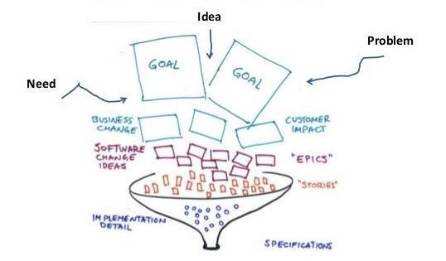

Fig.19: User Story Life Cycle

20

CHAPTER-10

USER STORY CARDS

10.1 |  | Epic – I User Story Card (Informal):
 |  |  |  |  |  | EPIC – I
 | S. |  |  |  |  | User Story |  |  | Priority
 | No. |  |  |  |  |  |  |  | Priority
 | No. |  | User |  |  | Task |  |  | Priority
 | 1 |  | Developer | Can access all the functionalities of setup |  |  |  |  | 1
 | 2 |  | Developer | Can record data and send to cloud by itself |  |  |  |  | 2.1
 | 3 |  | Developer | Can record data continuously |  |  |  |  | 2.2
 | 4 |  | Developer | Can access the web application |  |  |  |  | 2.3
 | 5 |  | Developer | Can retrieve the data from cloud |  |  |  |  | 2.4
 | 6 |  | End User | Can open the push notification with information |  |  |  |  | 3
 | 7 |  | End User | Can analyze and understand data |  |  |  |  | 3.1
 | 8 |  | End User | Can control the working status |  |  |  |  | 3.2
 |  |  |  |  |  | Table 10.1: User Story Card Epic-I
10.1 |  | Epic – II User Story Card (Informal):
 |  |  |  |  |  | EPIC – II
 | S. |  |  |  |  | User Story |  |  | Priority
 | No. |  |  |  |  |  |  |  | Priority
 | No. |  | User |  |  | Task |  |  | Priority
 | 1 |  | Developer | Can organize material for future use |  |  |  |  | 1
 | 2 |  | Developer | Can decide robust and efficient working of setup |  |  |  |  | 2
 | 3 |  | Developer | Can differentiate between the different data |  |  |  |  | 3
 | 3 |  | Developer | retrieved from different sensors. |  |  |  |  | 3
 | 4 |  | Developer | Can use the notification from land. |  |  |  |  | 2.3
 |  |  |  |  | Table 10.2: User Story Card EPIC-II
 |  |  |  |  |  |  |  |  | 21

CHAPTER-11

SOFTWARE REQUIREMENT SPECIFICATIONS

11.1 Introduction:

11.1 Purpose

To provide smart farming protection technique using Internet of Things so as to optimize consumption of resources with the help of analytical based water dripping system and restricts the interference of animals and creatures into the farming land. To provide the stakeholder access, to manage and view its resources states through the mobile based application interface.

11.2 Feasibility

Basically the problem is obliviousness of the farmer to the digital world and several solutions which they can adopt and take good care of their crops. This will help them go digital and manage their daily tasks at comfort.

This setup will generate an alarm in the application installed on the phone of the farmer if any interference is recorded in the farm so that he can take suitable actions. Apart from this, it will also automatically generate a notification which will be informing the farmer to start or stop the dripping in the field accordingly.

For this concept we will provide a hybrid app for Android interfaced with Hardware Setup installed on the farming land, so that the users can run the application and take proper care of his crops and agriculture land.

11.2 Functional/Non-functional requirement:

Functional/Non-functional for Advance Farming Solutions are as follows:

11.2.1 Functional requirements:

A functional requirement defines a function of a system or its component. A function is described as a set of inputs, the behavior, and outputs. Functional requirements may be calculations, technical details, data manipulation and processing and other specific functionality that define what a system is supposed to accomplish.

- A mobile application that can record data of happenings on the farming land and can monitor every occurrence

- The application should be able to retrieve results from setup installed comprising of various sensors from the data stored on the cloud

- The webpage should be bootstrapped and must be functional for both laptops and mobile phones.

22

11.2.2 Non-functional requirement:

A non-functional requirement (NFR) is a requirement that specifies criteria that can be used to judge the operation of a system, rather than specific behaviors. Non-functional requirements are often called "quality attributes" of a system. Other terms for non-functional requirements are "qualities", "quality goals", "quality of service requirements", "constraints" and "non-behavioral requirements".

- There should be minimal lag while recording the data from the land and sending over the cloud.

- The components installed on the ground must be properly functional

- The system should give valid result for positive as well as negative test cases
- The proposed system should be able to identify every change in the environment in every 1 minute.

11.3 Technical requirement:

Technical requirement is a requirement that specify the criteria that can be used to jdge the operating system, hardware compatibility, software requirements, system specifications, etc. for Advance Farming Solutions, the technical requirement are as follows:

11.3.1 Operating environment:

Our application could be operated on mobile platforms which includes – Android and IOS mobile interfaces and the device data stores on web servers i.e. Apache Web server , and it also includes Database servers which is deployed on cloud . All this runs effectively with Internet connectivity to upload access or compute data.

11.3.2 Hardware requirements:

- A smartphone Integrated internet with functionality
- A smartphone having minimum RAM as 500MB

- A laptop having minimum RAM as 4GB

- Various Sensors
- Connecting Wires

- NodeMCU

11.3.3 Software requirements:

- Linux OS is preferable else Windows OS or Mac OS is also used

- SDK of respective mobile platforms

- Various Plug-in(s)

23

11.4 Use-Case diagram:
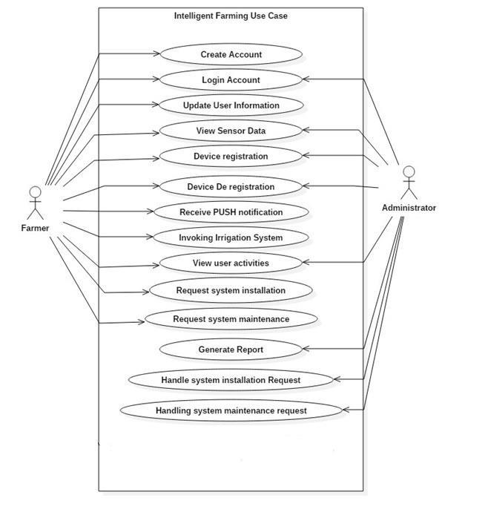

Fig.20: Use Case Diagram

24

11.5 Assumptions and Dependencies:

- End user has a smartphone with fully functional internet functionalities
- End user can use internet on phone

- The system here focuses controlling of farming land

25

CHAPTER-12

SPRINT BACKLOG – 1

12.1 Introduction to Spring Backlog - 1:

The sprint backlog is a list of tasks identified by the Scrum team to be completed during the Scrum sprint. This contains some modules, usually in the form of user stories, and identifies the tasks necessary to complete each user story. In this backlog - 1, we are providing the basic home screen to capture the image for further processing. An end user can capture an image and can see it in picture storage space/pane. To provide efficiency and robustness, application will automatically delete captured pictures after exiting the application.

12.2 Sprint Backlog Chart:

 |  |  |  |  | Status
Us | User | Task |  |  | (not | Estimated
er | User | Task | Tasks | TM | started/in | Date of Task
er | Story | ID
ID | Story | ID |  |  | progress/c | Completion
 |  |  |  |  | ompleted)
US | Realizing |  |  |  |  | 16-09-2018
US | the |  | Selection and |  |  | 16-09-2018
#0 | the | T#01 | Selection and | DA | Completed | 03-10-2018
#0 | hardware | T#01 | purchasing of equipment | DA | Completed | 03-10-2018
1 | hardware |  | purchasing of equipment
1 | needs
US | Collection |  | So the proper checking |  |  | 17-09-2018
#0 | and | T#02 | So the proper checking | SK | Completed | 17-09-2018
#0 | and | T#02 | and testing of products | SK | Completed
2 | assembly |  | and testing of products
US | To replace |  | So that the complete
US | the |  | So that the complete |  |  | 20-09-2018
#0 | the | T#03 | products can be | SM | Completed | 20-09-2018
#0 | defected
3 | defected |  | obtained
3 | products |  | obtained
US | To initiate |  | Designing how the |  |  | 25-09-2018
#0 | low level | T#04 | equipment will be | DA | Completed | 25-09-2018
4 | designing |  | embedded
US | Deciding |  | Framing of the design to |  |  | 27-09-2018
#0 | the basic | T#05 | Framing of the design to | SK | Completed | 27-09-2018
#0 | the basic | T#05 | embed the equipment | SK | Completed
5 | layout |  | embed the equipment
US | High level |  | Finalizing the design of |  |  | 05-10-2018
#0 | design of | T#06 | Finalizing the design of | SM | Completed | 05-10-2018
#0 | design of | T#06 | the circuitry OS | SM | Completed
6 | hardware |  | the circuitry OS
US | Implement |  | Putting the equipment
#0 | ation of | T#07 | Putting the equipment | DA | Completed | 08-10-2018
#0 | ation of | T#07 | to work for real | DA | Completed | 08-10-2018
7 | circuitry |  | to work for real
US | Testing of |  | Final testing for working
#0 | Testing of | T#08 | of all the devices | SK | Completed | 08-10-2018
#0 | the circuit
8 | the circuit |  | embedded

Table 12.1: Sprint Backlog Chart - 1

26

12.3 Collection of Hardware

In this module we have collected the hardware requirements of the project which is need to build or make the complete project setup functional. These hardware included collection of various sensors which majorly includes laser sensor, motion sensor, soil moisture content sensor and temperature humidity sensor.

We have tried our best to collect the best of the hardware requirements of the project and verified their functioning completely so that there is no chance of any malfunctioning and any harmful consequence. Every equipment was tried and tested before its placement on the circuitry and before putting it for actual use.

12.4 Low level design

Low level design consists of design of the complete project on the component-level that follows a stepwise procedure for the complement of a project. This is also used for designing data structures and the required software architecture which is basically will be used in the project.

Low level design basically comprises of the placement of all the equipment on the circuit board/ bread board for initiating the proper, safe and efficient use of the each equipment presented for the functioning of various systems required in the project.
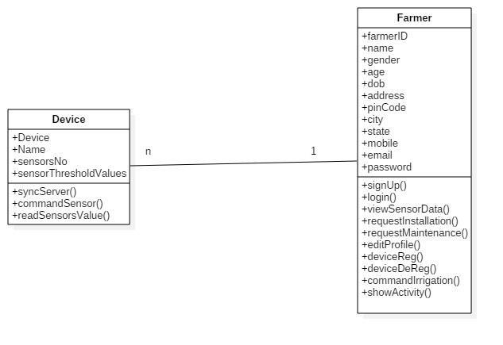

Fig.21: Class Diagram

27

12.5 High Level Design

High level design of the project basically tends towards the basic architecture or in simpler words, it is the basic and simple foundation of the complete project which helps the developer to make the software or the project in a particular flow.

It helps to understand the architecture of the complete project and helps to develop and create our work plan accordingly and as implied in the design.

The architecture diagram of the complete project provides the overview of the complete project and also of the entire system by recognizing the main and major components of the project which will be developed for the project and its interfaces.
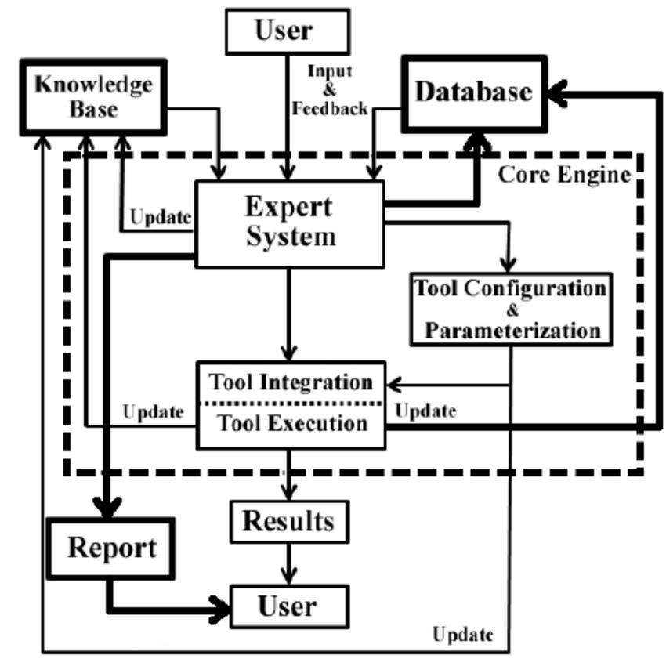

Fig.22: High Level Design

12.6 Conclusion:

All the mentioned tasks have been successfully done and verified by guide under practical circumstances. This module has covered the collection and assembly of hardware components required for the project and all the components are tested and verified for the practical use in the project.

28

CHAPTER-13

SPRINT BACKLOG - 2

13.1 Introduction to Sprint Backlog - 2:

The sprint backlog is a list of tasks identified by the Scrum team to be completed during the Scrum sprint. This contains some modules, usually in the form of user stories, and identifies the tasks necessary to complete each user story. In this backlog - 2, we are providing the study analysis of the technology for image processing. There are different technologies for this purpose hence a brief comparison is being also provided with respective advantages over each.

13.2 Sprint Backlog Chart:

 |  |  |  |  |  |  | Status
User |  | Task |  |  |  |  | (not | Estimated
User | User Story |  |  | Tasks | TM | started/in |  | Date of Task
ID | User Story | ID
ID |  |  |  |  |  | progress/c |  | Completion
 |  |  |  |  |  | ompleted)
US# | Understandin | T#01 |  | For the | DA | Completed |  | 09-10-2018
01 | g the needs |  |  | development of
 | of the module |  |  | application
US#0 | Analyzing the |  |  | For the purpose of | SM, |  |  | 15-12-2018
2 | ways to | T#02 |  | look & feel of app | SK | Completed
 | design
 | module
US# | Designing |  |  | For idea to code | DA, |  |  | 17-12-2018
03 | basic layout | T#03 |  | the application | SM | Completed
 |  |  |  | accordingly
US# | Designing the |  |  | To use the buttons | SK |  |  | 20-10-2018
04 | graphic | T#04 |  | in to embed in the |  | Completed
 | buttons for |  |  | home page of app
 | module
US# | Converting |  |  | Coding of home | DA, |  |  | 25-10-2018
05 | the design | T#05 |  | page which | SM | Completed
 | into coding |  |  | includes this
 |  |  |  | module
US# | Testing the | T#06 |  | Testing to check | SK, | Completed |  | 26-10-2018
06 | functionalities |  |  | proper functions of | DA
 |  |  |  | buttons
 |  |  | Table | 13.1: Sprint Backlog | Chart | - 2

29

13.3 Study:

Technologies used in this application development are studied and provided as follows:

13.3.1 Layout Designing

Image processing is a method to perform some operations on an image, in order to get an enhanced image or to extract some useful information from it. It is a type of signal processing in which input is an image and output may be image or characteristics/features associated with that image. In this project we are using digital image processing.

Digital image processing is the use of computer algorithms to perform image processing on digital images. As a subcategory or field of digital signal processing, digital image processing has many advantages over analog image processing. It allows a much wider range of algorithms to be applied to the input data and can avoid problems such as the build-up of noise and signal distortion during processing. Since images are defined over two dimensions (perhaps more) digital image processing may be modeled in the form of multidimensional systems.

Out of all these signals, the field that deals with the type of signals for which the input is an image and the output is also an image is done in image processing. As it name suggests, it deals with the processing on images.

It can be further divided into analog image processing and digital image processing.

13.3.2 Coding (HTML/CSS/Bootstrap)

HTML is the standard markup language for creating Web pages. HTML stands for Hyper Text Markup Language. HTML describes the structure of Web pages using markup. Its elements are the building blocks of HTML pages. Its elements are represented by tags. HTML tags label pieces of content such as "heading", "paragraph", "table", and so on. Browsers do not display the HTML tags, but use them to render the content of the page. Now that we’ve gotten the basic theory out of the way. It’s time to learn how to build our first website.

First off, we must ensure that we have the right tools. Most importantly, we need an HTML editor. There are many choices on the market such as the extremely popular Notepad++. However, for this tutorial, we will use the Bluefish Editor as it is free and also offers cross platform support for Windows, Mac, and Linux users. If you don't want to install any software, but want to preview code instantly — you can use an online HTML editor such as this simple html5 editor.

Cascading Style Sheets or CSS which is used to enhancing the presentation of a webpage to a great extent and which is basically used to decorate the pages to make them look beautiful and attractive.

The major goal of CSS lies in the fact that it enables the separation of presentation and content including some layout which is properly padded, colors and fonts.

30

Its specifications and characteristics are maintained and managed by the World Wide Web Consortium.

It also has a simple syntax and also uses a number English language words to specify the names and properties of the functions and methods in the sheets. It actually consists a long list of rules and each of them consists of different rule set used to make up a single sheet and declaration blocks. The major goal of CSS lies in the fact that it enables the separation of presentation and content including some layout which is properly padded, colors and fonts. Its specifications and characteristics are maintained and managed by the World Wide Web Consortium.

The major goal of CSS lies in the fact that it enables the separation of presentation and content including some layout which is properly padded, colors and fonts.

Its specifications and characteristics are maintained and managed by the World Wide Web Consortium. Cascading Style Sheets or CSS which is used to enhancing the presentation of a webpage to a great extent and which is basically used to decorate the pages to make them look beautiful and attractive.

Bootstrap is a completely free and open source framework which is used for front end purposes for the purpose of designing webpages and web applications. It constitutes of HTML and also CSS dependent design templates for the typography, forms, buttons, navigation and other purpose all and also is able to make the webpage functional on both the desktop screen as well as small sized cellphones also.

Bootstrap makes it feasible to use those web pages in both the formats and that too in a very simple format. Since it is free and openly available so everyone can use it and make the ir web application more catchy and feasible to work in any condition.

Bootstrap is a completely free and open source framework which is used for front end purposes for the purpose of designing webpages and web applications. It constitutes of HTML and also CSS dependent design templates for the typography, forms, buttons, navigation and other purpose all and also is able to make the webpage functional on both the desktop screen as well as small sized cellphones also.

13.3.2.1 Advantages:

- The web application will be able to interact with user

- The user will be able to easily access it on laptop and also on mobile

- The login page is simple to fill and interface
- The user will easily operate it even when he/she is illiterate.

31

13.4 Arduino Based Code for Hardware Setup:

#include "Adafruit_MQTT.h" #include "Adafruit_MQTT_Client.h" #include <ESP8266WiFi.h> #include <ESP8266HTTPClient.h>

#define AIO_SERVER "io.adafruit.com" #define AIO_SERVERPORT 1883 #define AIO_USERNAME "agarwal2796"

#define AIO_KEY "884e526ec99f48cb83277b51a5f4b570"

WiFiClient client;

WiFiClient client2;

Adafruit_MQTT_Client mqtt(&client2, AIO_SERVER, AIO_SERVERPORT, AIO_USERNAME, AIO_KEY); boolean MQTT_connect();

boolean MQTT_connect()

{ int8_t ret;

if (mqtt.connected())

{ return true; } uint8_t retries = 3;

while ((ret = mqtt.connect()) != 0) { mqtt.disconnect();

delay(2000);

retries--;

if (retries == 0)

{ return false; } } return true;}

Adafruit_MQTT_Publish msg = Adafruit_MQTT_Publish(&mqtt, AIO_USERNAME "/feeds/sm");

String thingSpeakAddress= "http://api.thingspeak.com/update?";

String writeAPIKey;

String tsfield1Name;

String request_string;

HTTPClient http;

#include <dht.h>

#define dataPin 16

dht DHT;

int value= 0;

int val;

void setup() {

Serial.begin(115200);

32

WiFi.disconnect();

delay(2000);

WiFi.begin("Connection Error","jiodhandhan"); while((!(WiFi.status() == WL_CONNECTED))) {

delay(300);

Serial.print("..");

}

Serial.println("Connected");

Serial.println("Your IP is");

Serial.println((WiFi.localIP().toString()));

}

void loop() {

///////SOIL MOISTURE

value= analogRead(0);

val=(1024 - value);

val=val*100;

val=val/1024;

Serial.print("MOISTURE LEVEL :");

Serial.print(val);

Serial.println(" % ");

if (MQTT_connect()) {

if (msg.publish(val)) { Serial.println("SM data sent");

} else {

Serial.println("Problem to send SM Data");

}

}

////////////DHT

int readData = DHT.read22(dataPin); // Reads the data from the sensor

float t = DHT.temperature; // Gets the values of the temperature

float h = DHT.humidity; // Gets the values of the humidity Serial.print("Temperature = ");

Serial.print(t);

Serial.print(" *C ");

Serial.print(" Humidity = ");

Serial.print(h);

Serial.println(" % ");

delay(15000);

if (client.connect("api.thingspeak.com",80)) {

33

request_string = thingSpeakAddress;

request_string += "key=";

request_string += "CME3C58I3BDS894A";

request_string += "&";

request_string += "field1";

request_string += "=";

request_string += val;

http.begin(request_string);

http.GET();

http.end();

delay(15000);

request_string = thingSpeakAddress;

request_string += "key=";

request_string += "CME3C58I3BDS894A";

request_string += "&";

request_string += "field2";

request_string += "=";

request_string += t;

http.begin(request_string);

http.GET();

http.end();

delay(15000);

request_string = thingSpeakAddress;

request_string += "key=";

request_string += "CME3C58I3BDS894A";

request_string += "&";

request_string += "field3";

request_string += "=";

request_string += h;

http.begin(request_string);

http.GET();

http.end();

}

}

34

35

13.4 Arduino Based Code for Graphical User Interface (GUI):

#include <ESP8266WiFi.h> #include "Adafruit_MQTT.h" #include "Adafruit_MQTT_Client.h"

const char* ssid | = | "Connection Error";
const char* password = |  | "jiodhandhan";
#define AIO_SERVER |  | "io.adafruit.com"
#define AIO_SERVERPORT |  | 1883
#define AIO_USERNAME |  | "agarwal2796"
#define AIO_KEY | "884e526ec99f48cb83277b51a5f4b570"

WiFiClient client;

WiFiServer server(80);

Adafruit_MQTT_Client mqtt(&client, AIO_SERVER, AIO_SERVERPORT, AIO_USERNAME, AIO_KEY);

boolean MQTT_connect();

boolean MQTT_connect()

{ int8_t ret;

if (mqtt.connected())

{ return true; } uint8_t retries = 3;

while ((ret = mqtt.connect()) != 0) { mqtt.disconnect();

delay(2000);

retries--;

if (retries == 0)

{ return false; }

36

} return true;}

Adafruit_MQTT_Publish pump = Adafruit_MQTT_Publish(&mqtt, AIO_USERNAME "/feeds/pump");

- Variable to store the HTTP request String header;

String pumpState = "off"; void setup() {

Serial.begin(115200); WiFi.begin(ssid, password);

while (WiFi.status() != WL_CONNECTED) { delay(500);

Serial.print(".");

}

  - Print local IP address and start web server Serial.println("");

Serial.println("WiFi connected."); Serial.println("IP address: "); Serial.println(WiFi.localIP());

server.begin();

}

void loop(){

37

WiFiClient client = server.available(); incoming clients

// Listen for

if (client) {

connects,

// If a new client

Serial.println("New Client."); out in the serial port

// print a message

String currentLine = "";

to hold incoming data from the client

// make a String

while (client.connected()) { client's connected

// loop while the

if (client.available()) { bytes to read from the client,

// if there's

char c = client.read();

// read a byte,

then

Serial.write(c); the serial monitor

// print it out

header += c;

if (c == '\n') { a newline character

// if the byte is

- if the current line is blank, you got two newline characters in a row.

- that's the end of the client HTTP request, so send a response:

if (currentLine.length() == 0) {

- HTTP headers always start with a response code (e.g. HTTP/1.1 200 OK)

- and a content-type so the client knows what's coming, then a blank line:

client.println("HTTP/1.1 200 OK");

client.println("Content-type:text/html");

client.println("Connection: close");

38

client.println();

///pump CONTROL

if (header.indexOf("GET /pump/on") >= 0){

if (MQTT_connect()) {

if (pump.publish(1)) {

Serial.println("Pump ON");

pumpState="on";

}

}

}

else if(header.indexOf("GET /pump/off") >= 0){

if (MQTT_connect()) {

if (pump.publish(0)) {

pumpState="off";

Serial.println("Pump OFF");

}

}

}

// Display the HTML web page

client.println("<!DOCTYPE html><html><head><title>Advanced Farming Solution</title><meta charset=\"utf-8\">");

client.println("<meta name=\"viewport\"

content=\"width=device-width, initial-scale=1\"><link

rel=\"stylesheet\"

href=\"https://maxcdn.bootstrapcdn.com/bootstrap/3.3.7/css/boo

tstrap.min.css\">");

39

client.println("<script

src=\"https://ajax.googleapis.com/ajax/libs/jquery/3.3.1/jquer

y.min.js\"></script><script

src=\"https://maxcdn.bootstrapcdn.com/bootstrap/3.3.7/js/boots

trap.min.js\"></script><style type=\"text/css\">");

client.println(".button { background-color: #195B6A; border:

none; color: white; padding: 16px 40px;text-decoration: none;

font-size: 30px; margin: 2px; cursor: pointer; } .blocks {

border: 1px solid #cccccc; width:450px; height:250px;text-

align: center; }</style></head><body>");

client.println("<div class=\"row\"> <h2 align=\"center\">Advanced Farming Solutions</h2> </div><div class=\"row\"><div class=\"col-sm-4\"><p align=\"center\">Soil Mositure</p><iframe width=\"450\" height=\"260\" style=\"border: 1px solid #cccccc;\" src=\"https://thingspeak.com/channels/602453/widgets/16899\">< /iframe></iframe><br>");

client.println("</div><div class=\"col-sm-4\"><p align=\"center\">Temperature</p><iframe width=\"450\" height=\"260\" style=\"border: 1px solid #cccccc;\" src=\"https://thingspeak.com/channels/602453/widgets/16900\">< /iframe><br></div>");

client.println("<div class=\"col-sm-4\"><p align=\"center\">Humidity</p><iframe width=\"450\" height=\"260\" style=\"border: 1px solid #cccccc;\" src=\"https://thingspeak.com/channels/602453/widgets/16901\">< /iframe></div></div><br><div class=\"row\">");

client.println("<div class=\"col-sm-4\"><div class=\"blocks\" ><h3>Water Pump Control</h3><br>");

if(pumpState=="off")

{

client.println("<a href=\"/pump/on\"> <button class=\"button\">ON</button></a><p>Pump State:" + pumpState + "</p>");

}

else{

40

client.println("<a href=\"/pump/off\"> <button class=\"button\">OFF</button></a><p>Pump State:" + pumpState + "</p>");

}

client.println("</div></div><div class=\"col-sm-4\"><div class=\"blocks\" ><h3>Border Security</h3><br><p>Security Status:</p></div></div><div class=\"col-sm-4\"><div class=\"blocks\" ><h3>Aerial Security</h3><br><p>Security Status:</p></div></div></div></body></html>");

client.println("");

- The HTTP response ends with another blank line client.println();

- Break out of the while loop

break;

} else { // if you got a newline, then clear currentLine

currentLine = "";

}

} else if (c != '\r') { // if you got anything else but a carriage return character,

currentLine += c; currentLine

// add it to the end of the

}

}

}

- Clear the header variable header = "";

- Close the connection client.stop(); Serial.println("Client disconnected.");

41

Serial.println("");

}

}

42

CHAPTER-14

ACHIEVEMENTS- MODULE REQUIREMENTS VS FULFILLED REQUIREMENTS

43

CHAPTER-15

DETAILED REPORT FROM CLIENT AND RECOMMENDATION

44

CHAPTER-16

REPORT FROM GUIDE AND RECOMMENDATION

45

CHAPTER-17

FUTURE SCOPE OF WORK

As future scope, The Advance Farming Solutions is a project which will help the farmers to do the farming and the daily tasks associated to farming in a smart manner. We will be developing a hardware interface which will be installed on the farming land and an Android based application which will be installed in the smartphone of the farmer. This project has the objective to protect the crops from various damages caused by various factors which majorly include, lack of water or timely dripping of water in the land, trespassing of animals and creatures into the farming land and hence damaging the crops and human interference into farming land for some negative purposes.

This setup will generate an alarm in the application installed on the phone of the farmer if any interference is recorded in the farm so that he can take suitable actions. Apart from this, it will also automatically generate a notification which will be informing the farmer to start or stop the dripping in the field accordingly.

For this concept we will provide a hybrid app for Android interfaced with Hardware Setup installed on the farming land, so that the users can run the application and take proper care of his crops and agriculture land.

This project is meant to serve the farming community to protect their crops. It can be used in order to block any human or animal trespassing in the land. It is a productive initiative as it ensures the safety of the crops so that a farmer may not be put into any risks.

46

CHAPTER-18

FAQS ABOUT PROJECT

Q1: Does this setup will be able to notify the farmer?

A1: Yes, the farmer will be receiving a push notification for every activity happening on the farming land.

Q2: Does this setup perform any mechanical action?

A2: Yes, to threaten creatures or any trespassers coming on the farming land a buzzer will be ringing loudly.

Q3: Does this application/web page works on both laptop and mobile?

A3: Yes, since we have used bootstrap so the web page is easily functional on both laptop and mobile.

Q4: Does this setup works on different networks?

A4: No, the NodeMCU and the mobile must be connected to the same network to view and analyses the status of farming land.

Q5: is the data of activities is being recorded?

A5: Yes, the data is recorded and being uploaded on the cloud platform for every activity in duration of every one minute.

Q6: Does this setup also consists any photo related information?

A6: No, not currently but in future it can be added as an extension to this project.

Q7: Can anyone access any device?

A7: No, only the farmer having the IP address of the setup installed on ground can access.

Q8: Is the system of water dripping is automatic on the ground?

A8: Yes, as and when the soil moisture content goes below the threshold the water dripping will start automatically and a push notification will be received in the application of farmer.

47

CHAPTER-19

PROJECT SUMMARY

The Advance Faming Solutions is a project which will help the farmers to do the farming and the daily tasks associated to farming in a smart manner. We will be developing a hardware interface which will be installed on the farming land and an Android based application which will be installed in the smartphone of the farmer. This project has the objective to protect the crops from various damages caused by various factors which majorly include, lack of water or timely dripping of water in the land, trespassing of animals and creatures into the farming land and hence damaging the crops and human interference into farming land for some negative purposes.

This setup will generate an alarm in the application installed on the phone of the farmer if any interference is recorded in the farm so that he can take suitable actions. Apart from this, it will also automatically generate a notification which will be informing the farmer to start or stop the dripping in the field accordingly.

For this concept we will provide a hybrid app for Android interfaced with Hardware Setup installed on the farming land, so that the users can run the application and take proper care of his crops and agriculture land.

48

CHAPTER-20

APPENDICES

S.No. | Abbr. form/ |  | Meaning
S.No. | Term
1 | App |  | Application
2 | DB |  | Database
3 | Etc |  | Et cetera
4 | No. |  | Number
5 | Config |  | Configuration
6 | IDE |  | Integrated Development Environment
7 | CSS |  | Cascade Style Sheet
8 | HTML |  | Hyper Text Mark-Up Language
9 | OS |  | Operating System
10 | API |  | Application Programming Interface
11 | Sys |  | System
12 | Info |  | Information
 |  | Table | 20.1: Appendices

49

CHAPTER-21

REFERENCES

- https://en.wikipedia.org/wiki/NodeMCU#/media/File:NodeMCU_DEVKIT_1.0.jpg

- https://getbootstrap.com/

- https://en.wikipedia.org/wiki/Cascading_Style_Sheets

- www.guru99.com

- www.thegeekdiary.com

- www.edureka.com

- www.youtube.com

50

